DOKUMEN IMPLEMENTASI SISTEM

Quiff

untuk:

Quiffers Studio

Dipersiapkan oleh:

Vinsensius I Made Surya Aditya (190030097)

Program Studi Sistem Komputer

Institut Teknologi dan Bisnis

STIKOM Bali

2020

|  |  |  |  |  |
| --- | --- | --- | --- | --- |
| Logo Baru | Program Studi Sistem Komputer  ITB STIKOM Bali | Nomor Dokumen | | Halaman |
| *DIS-001* | | *44* |
| Revisi | *00* | *Tgl: 11 Dec 2020* |

**DAFTAR IS**

I. IMPLEMENTASI BASIS DATA 3

1.1 Implementasi Basis Data 3

1.2 Relasi Antartabel 5

II. IMPLEMENTASI ANTARMUKA 5

1.1 Halaman Spesifikasi Fungsi/Proses F.01 5

1.2 Halaman Sign Up Fungsi/Proses F.01.1 7

1.3 Halaman Daftar Kuis Fungsi/Proses F.02 9

1.4 Halaman Ikuti Kuis Fungsi/Proses 02.1 13

1.5 Halaman Review Kuis Fungsi/Proses F.0.3 16

1.6 Halaman Tambah User Fungsi/Proses F.0.4 26

1.7 Halaman Mengubah Data User Fungsi/Progres F.0.4.2 29

1.8 Halaman Menambah Data Kuis Fungsi/Progres F.0.5 31

1.9 Halaman Ubah Kuis Fungsi/Progres F.0.5.2 34

1.10 Halaman Buat Soal Kuis Fungsi/Progres F.0.5.3 38

**DAFTAR GAMBAR**

Gambar 1 Relasi Antar Tabel 5

Gambar 2 Halaman Login 6

Gambar 3 Halaman Sign-Up 8

Gambar 4 Halaman Daftar Kuis 10

Gambar 5 Halaman Ikuti Kuis 13

Gambar 6 Halaman Review Kuis 18

Gambar 7 Halaman Tambah User 26

Gambar 8 Halaman Mengubah Data User 29

Gambar 9 Halaman Menambah Data Kuis 31

Gambar 10 Halaman Ubah Kuis 34

Gambar 11 Halaman Buat Soal Kuis 39

**DAFTAR TABEL**

Tabel 1 Database 5

Tabel 2 Kode Program - Login 7

Tabel 3 Kode Program – SignUp 9

Tabel 4 Kode Program - Daftar Kuis 12

Tabel 5 Kode Program – Ikuti Kuis 15

Tabel 6 Kode Program - Review Kuis 25

Tabel 7 Kode Program - Tambah User 29

Tabel 8 Kode Program - Mengubah Data User 31

Tabel 9 Kode Program - Menambah Data Kuis 33

Tabel 10 Kode Program - Ubah Kuis 38

Tabel 11 Kode Program - Buat Soal Kuis 43

# **IMPLEMENTASI BASIS DATA**

## **Implementasi Basis Data**

|  |
| --- |
| CREATE TABLE `daftar_kuis` (  `id_kuis` int(11) NOT NULL,  `nama_kuis` varchar(150) NOT NULL,  `id_user` int(11) NOT NULL  )  INSERT INTO `daftar_kuis` (`id_kuis`, `nama_kuis`, `id_user`) VALUES  (7, 'Kuis 2 ', 1),  (9, 'quis test 7', 1),  (11, 'Kuis 1', 2);  CREATE TABLE `nilai` (  `id_nilai` int(11) NOT NULL,  `tgl` timestamp NOT NULL DEFAULT current_timestamp(),  `id_kuis` int(11) NOT NULL,  `username` varchar(20) NOT NULL,  `nilai` decimal(4,0) NOT NULL  )  INSERT INTO `nilai` (`id_nilai`, `tgl`, `id_kuis`, `username`, `nilai`) VALUES  (3, '2020-05-30 07:36:51', 11, 'user1', '100');  CREATE TABLE `soal` (  `id_soal` int(11) NOT NULL,  `no` int(11) NOT NULL,  `pertanyaan` text DEFAULT NULL,  `ansa` varchar(600) DEFAULT NULL,  `ansb` varchar(600) DEFAULT NULL,  `ansc` varchar(600) DEFAULT NULL,  `ansd` varchar(600) DEFAULT NULL,  `jawaban` int(11) DEFAULT NULL,  `id_kuis` int(11) NOT NULL  )  INSERT INTO `soal` (`id_soal`, `no`, `pertanyaan`, `ansa`, `ansb`, `ansc`, `ansd`, `jawaban`, `id_kuis`) VALUES  (1, 1, 'jawaban b', 'a', 'a', 'a', 'a', 2, 2),  (2, 2, 'jawaban c', 'c', 'c', 'c', 'c', 3, 2),  (3, 3, 'd', 'd', 'd', 'd', 'd', 4, 2),  (4, 1, 'A', 'A', 'b', 'c', 'd', 1, 3),  (5, 2, 'a', 'a', 'b', 'c', 'd', 1, 3),  (6, 3, 'a', 'a', 'b', 'c', 'd', 1, 3),  (7, 1, 'Contoh Pertanyaan Jawaban A', 'a', 'a', 'a', 'a', 1, 10),  (8, 2, 'Contoh Pertanyaan Jawaban A', 'a', 'a', 'a', 'a', 1, 10),  (10, 1, 'jawaban a', 'a', 'a', 'a', 'a', 1, 11),  (11, 2, 'jawaban A', 'a', 'a', 'a', 'a', 1, 11),  (12, 3, 'jawaban A', 'a', 'a', 'aa', 'a', 1, 11),  (13, 4, 'jawaban A', 'a', 'a', 'a', 'a', 1, 11),  (14, 5, 'jawaban A', 'aa', 'a', 'a', 'a', 1, 11),  (15, 1, 'jawaban b', 'a', 'a', 'a', 'a', 2, 7),  (16, 2, 'jawaban b', 'a', 'a', 'a', 'a', 2, 7),  (17, 3, 'jawaban b', 'a', 'a', 'a', 'a', 2, 7);  CREATE TABLE `user` (  `id_user` int(5) NOT NULL,  `username` varchar(20) NOT NULL,  `nama` varchar(30) NOT NULL,  `password` varchar(255) NOT NULL,  `email` varchar(35) NOT NULL,  `level` int(1) NOT NULL  )  INSERT INTO `user` (`id_user`, `username`, `nama`, `password`, `email`, `level`) VALUES  (1, 'admin', 'Administrator', '$2y$10$zrke9MVhKYAEqll23bVL1.FQZ5G7gcyIXDDep4mcQvxc2sdy8yQhC', 'admin', 0),  (2, 'user1', 'User1', '$2y$10$ulFVX3yQFjJtzccJ2LgFzehZ4z220aBJOx5VlA3asXPwGMUK8043G', 'user1@gmail.com', 1);  ALTER TABLE `daftar_kuis`  ADD PRIMARY KEY (`id_kuis`);  ALTER TABLE `nilai`  ADD PRIMARY KEY (`id_nilai`);  ALTER TABLE `soal`  ADD PRIMARY KEY (`id_soal`);  ALTER TABLE `user`  ADD PRIMARY KEY (`id_user`),  ADD UNIQUE KEY `username` (`username`);  ALTER TABLE `daftar_kuis`  MODIFY `id_kuis` int(11) NOT NULL AUTO_INCREMENT, AUTO_INCREMENT=12;  ALTER TABLE `nilai`  MODIFY `id_nilai` int(11) NOT NULL AUTO_INCREMENT, AUTO_INCREMENT=4;  ALTER TABLE `soal`  MODIFY `id_soal` int(11) NOT NULL AUTO_INCREMENT, AUTO_INCREMENT=18;  ALTER TABLE `user`  MODIFY `id_user` int(5) NOT NULL AUTO_INCREMENT, AUTO_INCREMENT=3;  COMMIT; |

Tabel Database

## **Relasi Antartabel**

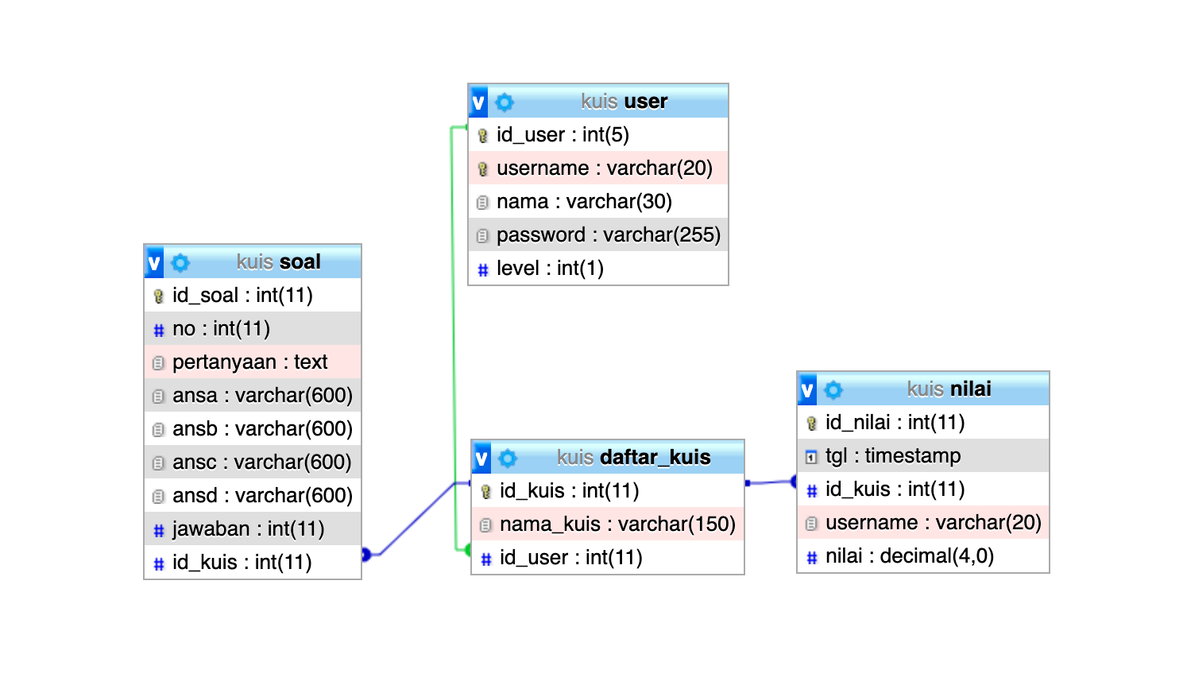

Gambar Relasi Antar Tabel

# **IMPLEMENTASI ANTARMUKA**

## **Halaman Spesifikasi Fungsi/Proses F.01**

Halaman Login dapat dilihat pada Gambar 1.1.

Pada halaman ini proses masuk kedalam aplikasi dilakukan untuk semua User

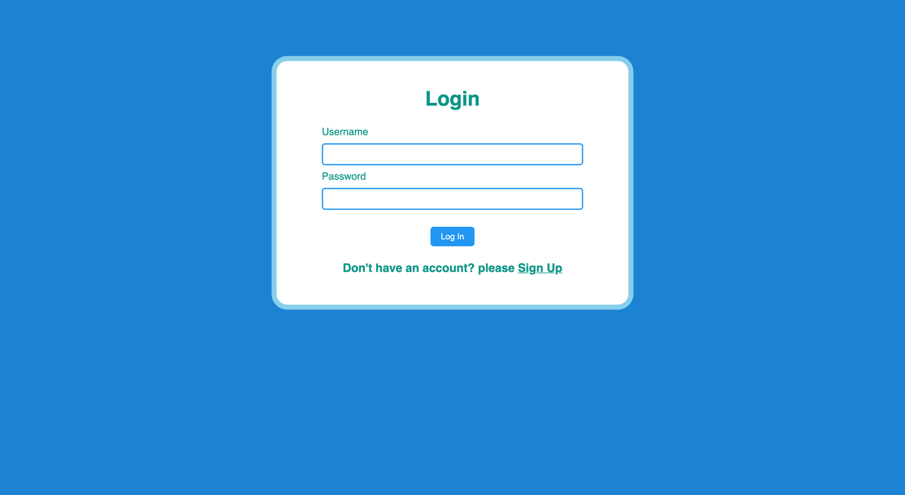

Gambar Halaman Login

|  |
| --- |
| <!DOCTYPE html>  <html>  <head>  <title>Quiff</title>  <link rel="stylesheet" type="text/css" href="style.css">  <script type="text/javascript">  function validateForm1() {  *var* a = document.forms["login"]["username"].value;  *var* b = document.forms["login"]["password"].value;    if (a == "") {  alert("Username must be filled out");  *return* false;  }    if (b == "") {  alert("Password must be filled out");  *return* false;  }    }  </script>  </head>  <body>  <div class="login teal">  <h1 class="center">Login</h1>  <form action="login.php" method="post" name="login" onsubmit="*return* validateForm1()">  <div class="left paddingtopbottom teal">Username</div>  <div class="center paddingtopbottom">  <input class = "inputbox teal" type="text" name="username" size="44" required>  </div>  <div class="left paddingtopbottom teal">Password</div>  <div class="center paddingtopbottom">  <input class="inputbox teal" type="password" name="password" size="44" required><br>  </div>  <br>  <div class="center paddingtopbottom">  <input class="button" type="submit" name="login" value="Log In">  </div>  </form>  <h3 class="center teal">Don't have an account? please <a href="signuppage.php" class="a">Sign Up</a></h3>    </div>  </body>  </html> |

Tabel Kode Program - Login

## **Halaman Sign Up Fungsi/Proses F.01.1**

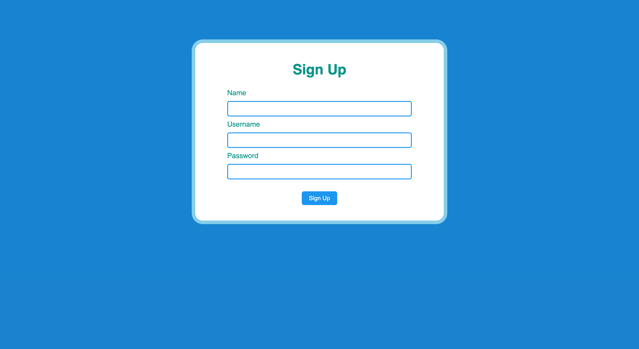

Gambar Halaman Sign-Up

|  |
| --- |
| <!DOCTYPE html>  <html>  <head>  <title>Quiff</title>  <link rel="stylesheet" type="text/css" href="style.css">  <script type="text/javascript">  function validateForm1() {  *var* a = document.forms["signup"]["username"].value;  *var* b = document.forms["signup"]["password"].value;  *var* c = document.forms["signup"]["nama"].value;  if (c == "" || b == "" || a == "") {  alert("Lengkapi semua field.");  *return* false;  }  }  </script>  </head>  <body>    <br><br><br><br><br>  <div class="login teal">  <h1 class="center">Sign Up</h1>  <form action="signup.php" method="post" name="signup" onsubmit="*return* validateForm1()">  <div class="left paddingtopbottom teal">Name</div>  <div class="center paddingtopbottom">  <input class = "inputbox teal" type="text" name="nama" size="44">  </div>  <div class="left paddingtopbottom teal">Username</div>  <div class="center paddingtopbottom">  <input class = "inputbox teal" type="text" name="username" size="44">  </div>  <div class="left paddingtopbottom teal">Password</div>  <div class="center paddingtopbottom">  <input class="inputbox teal" type="password" name="password" size="44"><br>  </div>  <br>  <div class="center paddingtopbottom">  <input class="button" type="submit" name="signup" value="Sign Up">  </div>  </form>  </h3>  </div>  </body>  </html> |

Tabel Kode Program – SignUp

## **Halaman Daftar Kuis Fungsi/Proses F.02**

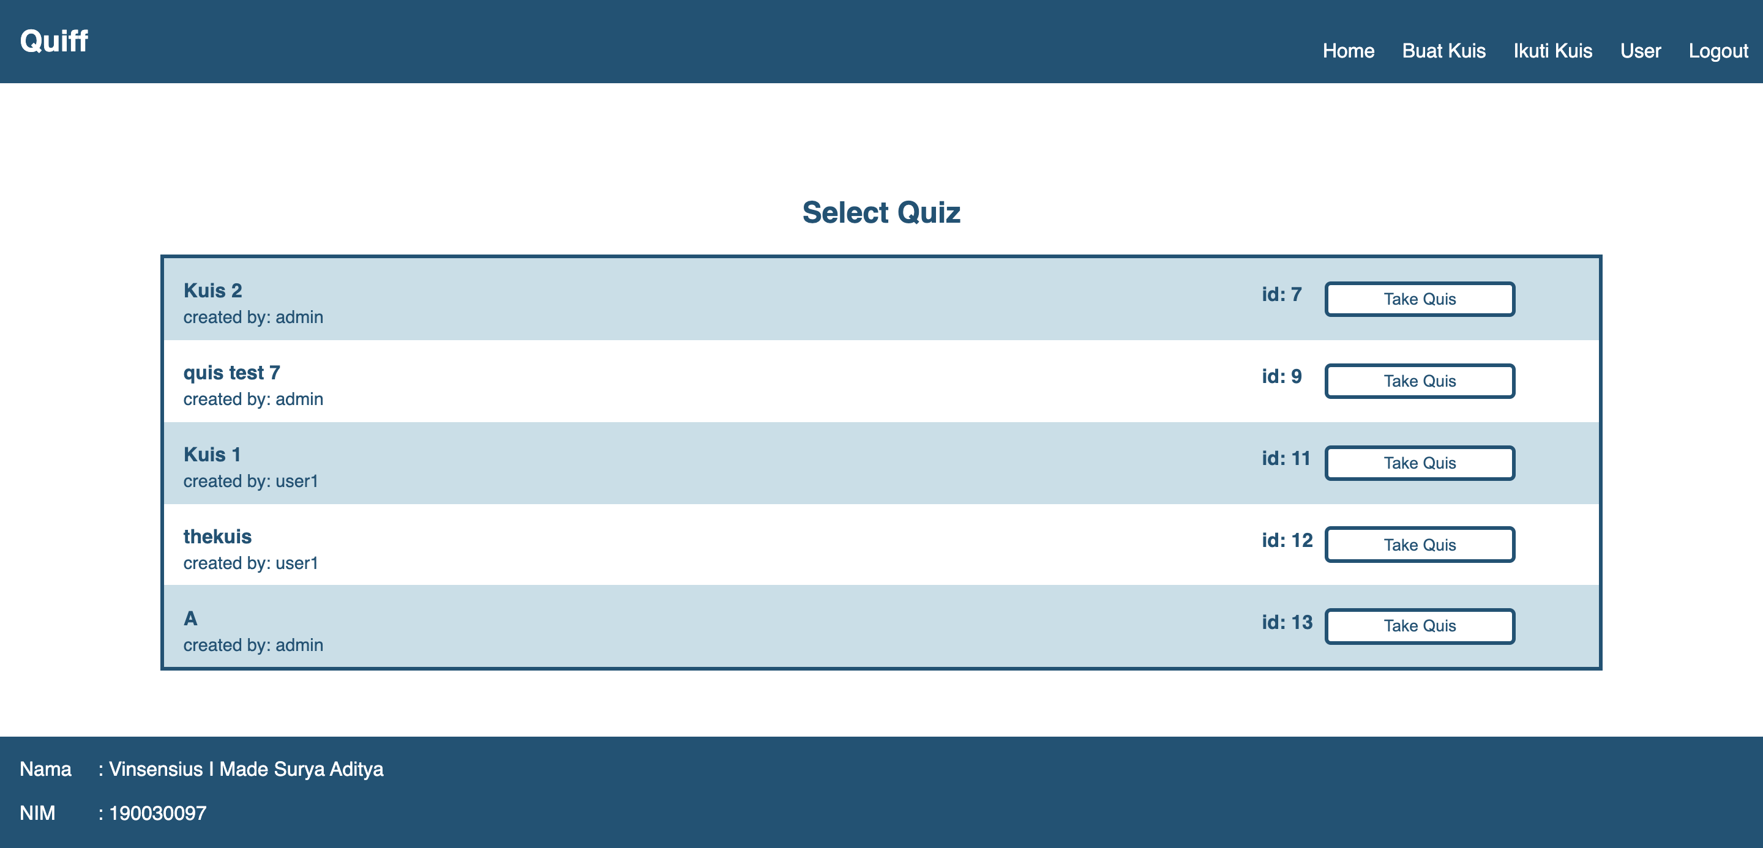

Gambar Halaman Daftar Kuis

|  |
| --- |
| <!DOCTYPE html>  <html>  <head>  <title>Quiff</title>  <link rel="stylesheet" type="text/css" href="style.css">  </head>  <body class="body1">  <div class="topnav">  <div class="container col c5">  <h2>Quiff</h2>  </div>  <div class="col c17">  <a class="container" href="logout.php">Logout</a>  <a class="container" href="usercontrol.php">User</a>  <a class="container" href="selectquispage.php">Ikuti Kuis</a>  <a class="container" href="createpage.php">Buat Kuis</a>  <a class="container" href="homepage.php">Home</a>  </div>  </div>      </body>  </html>  <!DOCTYPE html>  <html>  <body class="body1">    <h2 class="color-blue2 center">Select Quiz</h2>  <div class="container space col c2">  <br>  </div>  <div class="box col c18">  <form action="actionkuis.php" method="post">  <div class="container color-blue3">  <div class=" col c17"><br>  <strong >Kuis 2 </strong><br>  <div style="padding-top:0.5%; font-size:0.9em;">created by: admin</div>  </div>  <h4 class="col c1">id: 7 </h4>  <button type="submit" name="edit" value="7"class="button2 margin col c3 center">  <div class="container">Take Quis</div>  </button>  <div class="container space col c1"></div>  </div>    <div class="container color-blue4">  <div class=" col c17"><br>  <strong >quis test 7</strong><br>  <div style="padding-top:0.5%; font-size:0.9em;">created by: admin</div>  </div>  <h4 class="col c1">id: 9 </h4>  <button type="submit" name="edit" value="9"class="button2 margin col c3 center">  <div class="container">Take Quis</div>  </button>  <div class="container space col c1"></div><br>  </div>    <div class="container color-blue3">  <div class=" col c17"><br>  <strong >Kuis 1</strong><br>  <div style="padding-top:0.5%; font-size:0.9em;">created by: user1</div>  </div>  <h4 class="col c1">id: 11 </h4>  <button type="submit" name="edit" value="11"class="button2 margin col c3 center">  <div class="container">Take Quis</div>  </button>  <div class="container space col c1"></div>  </div>    <div class="container color-blue4">  <div class=" col c17"><br>  <strong >thekuis</strong><br>  <div style="padding-top:0.5%; font-size:0.9em;">created by: user1</div>  </div>  <h4 class="col c1">id: 12 </h4>  <button type="submit" name="edit" value="12"class="button2 margin col c3 center">  <div class="container">Take Quis</div>  </button>  <div class="container space col c1"></div><br>  </div>    <div class="container color-blue3">  <div class=" col c17"><br>  <strong >A</strong><br>  <div style="padding-top:0.5%; font-size:0.9em;">created by: admin</div>  </div>  <h4 class="col c1">id: 13 </h4>  <button type="submit" name="edit" value="13"class="button2 margin col c3 center">  <div class="container">Take Quis</div>  </button>  <div class="container space col c1"></div>  </div>  </form>  </div>    <div class="col c22"><br><br><br></div>  <div class="topnav footer container">  <div class="col c22"><br></div>  <div class="col c1 "> Nama</div>  <div class="col c21 ">: Vinsensius I Made Surya Aditya</div>  <div class="col c22"><br></div>  <div class="col c1 "> NIM</div>  <div class="col c21 ">: 190030097</div>  <div class="col c22"><br></div>  </body>  </html>  </body>  </html> |

Tabel Kode Program - Daftar Kuis

## **Halaman Ikuti Kuis Fungsi/Proses 02.1**

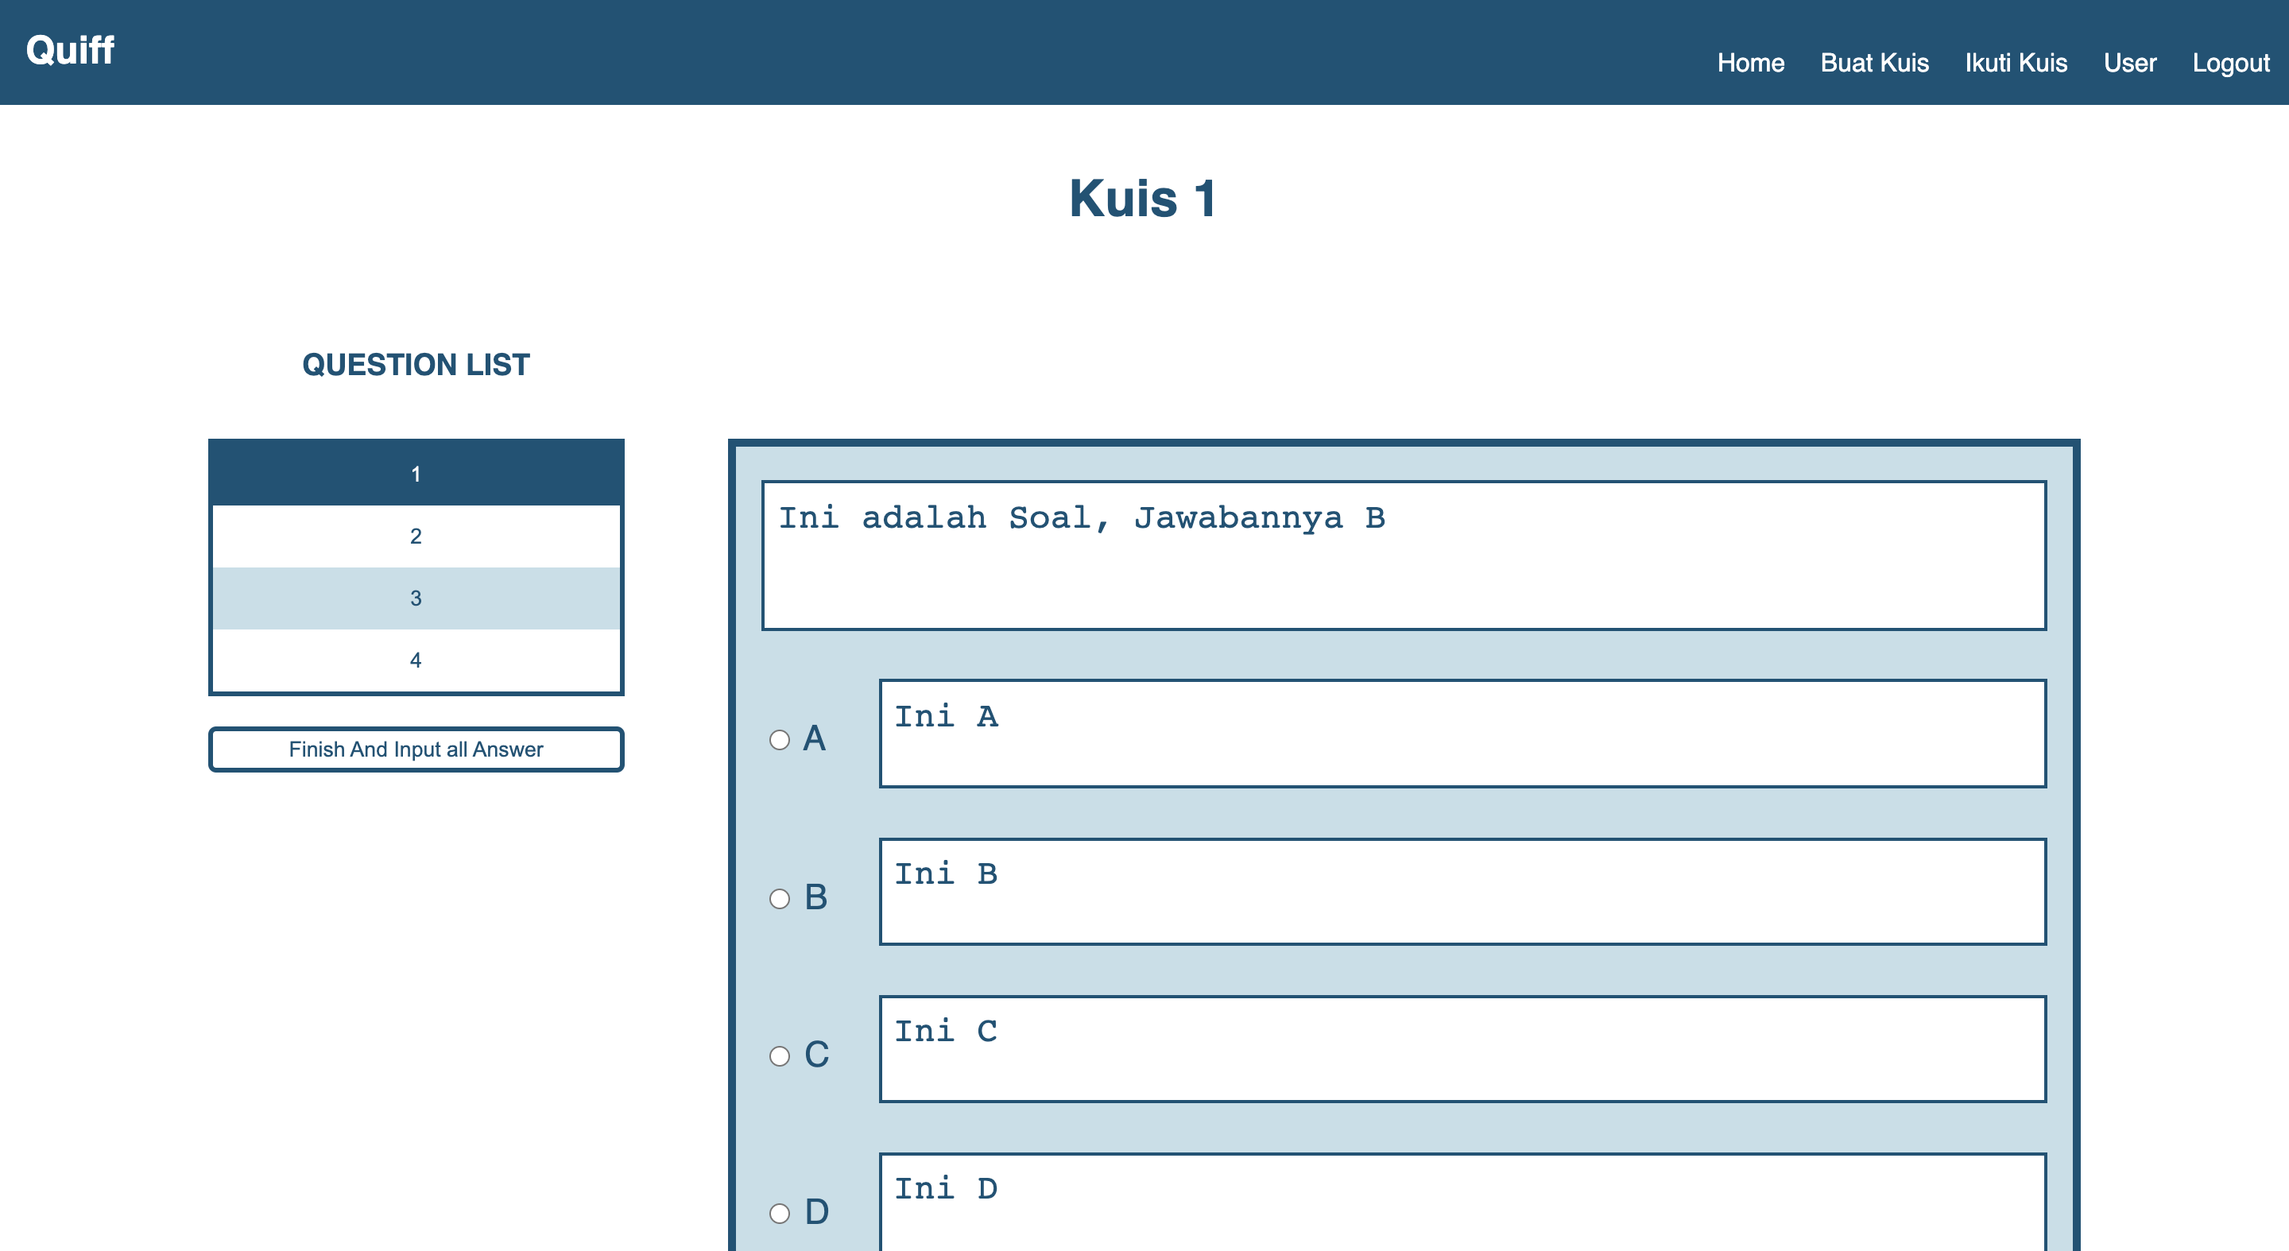

Gambar Halaman Ikuti Kuis

|  |
| --- |
| <!DOCTYPE html>  <html>  <head>  <title>Quiff</title>  <link rel="stylesheet" type="text/css" href="style.css">  </head>  <body class="body1">  <div class="topnav">  <div class="container col c5">  <h2>Quiff</h2>  </div>  <div class="col c17">  <a class="container" href="logout.php">Logout</a>  <a class="container" href="usercontrol.php">User</a>  <a class="container" href="selectquispage.php">Ikuti Kuis</a>  <a class="container" href="createpage.php">Buat Kuis</a>  <a class="container" href="homepage.php">Home</a>  </div>  </div>  <br><h1 class="color-blue4 center">Kuis 1</h1>  <br><br>  <div class="col c2 color-blue2"><br></div>  <div class="col c4">  <h3 class="color-blue2 center">QUESTION LIST</h3><br>  <div class="box">  <form method="get" action="review.php">  <button type="submit" formaction="answer.php" name= "id_soal" value=27 class=" button5" disabled>1</button><button type="submit" formaction="answer.php" name= "id_soal" value=28 class=" button4">2</button><button type="submit" formaction="answer.php" name="id_soal" value=29 class=" button3" >3</button><button type="submit" formaction="answer.php" name= "id_soal" value=30 class=" button4">4</button></div><button type="submit" name="Finish" value =1 class="button2 col c22 margin center" onclick="*return* confirm('Are you sure you want to finish this quis?');">  <div class="container" >Finish And Input all Answer</div></button>  </form>  </div>  <br><h3><br></h3>  <div class="col c1"><br></div>    </body>  </html><div class="col c13 box color-blue1">  <div class="container inputbox2">  <form action="answeraction.php" method="post">  <textarea rows="3" placeholder="Empty" cols="50" class="inputbox3" style="resize: none; background-color: #fff; padding: 1%" disabled>Ini adalah Soal, Jawabannya B</textarea>  <div class="container col c22"></div>  <div class="col c2 " ><br><br>  <input type="radio" id="A" name="answer" value="1" >  <label for="A" style="color: #245275">A</label>  </div>  <div class="col c20 "><br>  <textarea rows="2" cols="50" class="inputbox3 option" placeholder="Empty" name="pertanyaan" style="resize: none; background-color: #fff; padding:1%;" disabled>Ini A</textarea>  </div>  <div class="container col c22"></div>  <div class="col c2 " ><br><br>  <input type="radio" id="B" name="answer" value="2" >  <label for="B" style="color: #245275">B</label>  </div>  <div class="col c20 "><br>  <textarea rows="2" cols="50" class="inputbox3 option" placeholder="Empty" name="pertanyaan" style="resize: none; background-color: #fff; padding:1%;" disabled>Ini B</textarea>  </div>  <div class="container col c22"></div>  <div class="col c2 " ><br><br>  <input type="radio" id="C" name="answer" value="3" >  <label for="C" style="color: #245275">C</label>  </div>  <div class="col c20 "><br>  <textarea rows="2" cols="50" class="inputbox3 option" placeholder="Empty" name="pertanyaan" style="resize: none; background-color: #fff; padding:1%;" disabled>Ini C</textarea>  </div>  <div class="container col c22"></div>  <div class="col c2 " ><br><br>  <input type="radio" id="D" name="answer" value="4" >  <label for="D" style="color: #245275">D</label>  </div>  <div class="col c20 "><br>  <textarea rows="2" cols="50" class="inputbox3 option" placeholder="Empty" name="pertanyaan" style="resize: none; background-color: #fff; padding:1%;" disabled>Ini D</textarea>  </div>  <div class="container col c22"><br></div>  <div class="col c14" style="text-decoration: underline;">Soal No. 1</div>  <div >  <button type="submit" name= "id_soal" value=27,1,11,1, class="button2 col c4 center" style="margin-bottom:16px"><div class="container" style="padding:5px; ">Input & Previous</div></button>  </div>  <div class="col c1"><br></div>  <div >  <button type="submit" name= "id_soal" value=27,1,11,2, class="button2 col c3 center" style="margin-bottom:16px"><div class="container" style="padding:5px; ">Input & Next</div></button>  </div>  </form>  </div>  <div class="col c22"><br><br><br></div>  <div class="topnav footer container">  <div class="col c22"><br></div>  <div class="col c1 "> Nama</div>  <div class="col c21 ">: Vinsensius I Made Surya Aditya</div>  <div class="col c22"><br></div>  <div class="col c1 "> NIM</div>  <div class="col c21 ">: 190030097</div>  <div class="col c22"><br></div>  </body>  </html> |

Tabel Kode Program – Ikuti Kuis

## **Halaman Review Kuis Fungsi/Proses F.0.3**

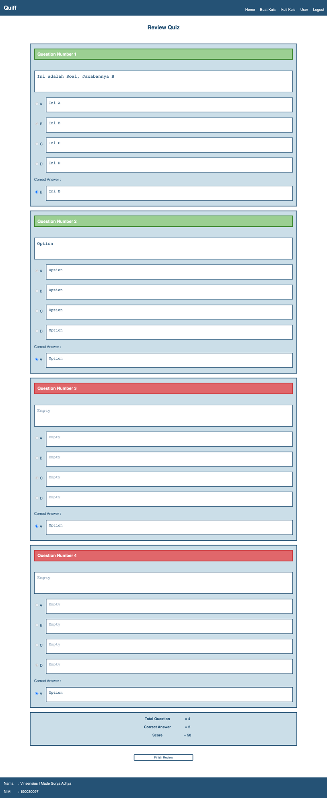

Gambar Halaman Review Kuis

|  |
| --- |
| <html>  <head>  <title>Quiff</title>  <link rel="stylesheet" type="text/css" href="style.css">  </head>  <body class="body1">  <div class="topnav">  <div class="container col c5">  <h2>Quiff</h2>  </div>  <div class="col c17">  <a class="container" href="logout.php">Logout</a>  <a class="container" href="usercontrol.php">User</a>  <a class="container" href="selectquispage.php">Ikuti Kuis</a>  <a class="container" href="createpage.php">Buat Kuis</a>  <a class="container" href="homepage.php">Home</a>  </div>  </div>  <br>  <h2 class="container center color-blue4">Review Quiz</h2>  <br>  <div class="container col c22"><br></div>  <div class="container space col c2"><br></div>  <div class="box col c18 color-blue1">  <div class="container ">  <form id="1">  <h3 class="container box color-green1" style="padding: 1%">Question Number 1</h3>  <textarea rows="3" placeholder="Empty" cols="50" class="inputbox3" style="resize: none; background-color: #fff; font-size: 1.5em; padding: 1%" disabled="">Ini adalah Soal, Jawabannya B</textarea>  <div class="container col c22"></div>  <div class="col c1 "><br><br>  <input type="radio" id="A" name="answer" value="1" disabled="">  <label for="A" style="color: #245275">A</label>  </div>  <div class="col c21 "><br>  <textarea rows="2" cols="50" class="inputbox3 option" placeholder="Empty" name="pertanyaan" style="resize: none; font-size:1.3em!important;background-color: #fff; padding:1%;" disabled="">Ini A</textarea>  </div>  <div class="container col c22"></div>  <div class="col c1 "><br><br>  <input type="radio" id="B" name="answer" value="2" checked="" disabled="">  <label for="B" style="color: #245275">B</label>  </div>  <div class="col c21 "><br>  <textarea rows="2" cols="50" class="inputbox3 option" placeholder="Empty" name="pertanyaan" style="resize: none; font-size:1.3em!important;background-color: #fff; padding:1%;" disabled="">Ini B</textarea>  </div>  <div class="container col c22"></div>  <div class="col c1 "><br><br>  <input type="radio" id="C" name="answer" value="3" disabled="">  <label for="C" style="color: #245275">C</label>  </div>  <div class="col c21 "><br>  <textarea rows="2" cols="50" class="inputbox3 option" placeholder="Empty" name="pertanyaan" style="resize: none; font-size:1.3em!important;background-color: #fff; padding:1%;" disabled="">Ini C</textarea>  </div>  <div class="container col c22"></div>  <div class="col c1 "><br><br>  <input type="radio" id="D" name="answer" value="4" disabled="">  <label for="D" style="color: #245275">D</label>  </div>  <div class="col c21 "><br>  <textarea rows="2" cols="50" class="inputbox3 option" placeholder="Empty" name="pertanyaan" style="resize: none; font-size:1.3em!important;background-color: #fff; padding:1%;" disabled="">Ini D</textarea>  </div>  <div class="container col c22"><br></div>  <div style="color: #245275">Correct Answer :</div>  <div class="col c1 "><br><br>  <input type="radio" id="B" name="Correct" value="4" checked="true">  <label for="B" style="color: #245275">B</label>  </div>  <div class="col c21 "><br>  <textarea rows="2" cols="50" class="inputbox3 option" placeholder="Empty" name="pertanyaan" style="resize: none; font-size:1.3em!important;background-color: #fff; padding:1%;" disabled="">Ini B</textarea>  </div>  <div class="container col c22"><br></div>  </form>  </div>  </div>  <div class="container col c22"><br></div>  <div class="container space col c2"><br></div>  <div class="box col c18 color-blue1">  <div class="container ">  <form id="2">  <h3 class="container box color-green1" style="padding: 1%">Question Number 2</h3>  <textarea rows="3" placeholder="Empty" cols="50" class="inputbox3" style="resize: none; background-color: #fff; font-size: 1.5em; padding: 1%" disabled="">Option</textarea>  <div class="container col c22"></div>  <div class="col c1 "><br><br>  <input type="radio" id="A" name="answer" value="1" checked="" disabled="">  <label for="A" style="color: #245275">A</label>  </div>  <div class="col c21 "><br>  <textarea rows="2" cols="50" class="inputbox3 option" placeholder="Empty" name="pertanyaan" style="resize: none; font-size:1.3em!important;background-color: #fff; padding:1%;" disabled="">Option</textarea>  </div>  <div class="container col c22"></div>  <div class="col c1 "><br><br>  <input type="radio" id="B" name="answer" value="2" disabled="">  <label for="B" style="color: #245275">B</label>  </div>  <div class="col c21 "><br>  <textarea rows="2" cols="50" class="inputbox3 option" placeholder="Empty" name="pertanyaan" style="resize: none; font-size:1.3em!important;background-color: #fff; padding:1%;" disabled="">Option</textarea>  </div>  <div class="container col c22"></div>  <div class="col c1 "><br><br>  <input type="radio" id="C" name="answer" value="3" disabled="">  <label for="C" style="color: #245275">C</label>  </div>  <div class="col c21 "><br>  <textarea rows="2" cols="50" class="inputbox3 option" placeholder="Empty" name="pertanyaan" style="resize: none; font-size:1.3em!important;background-color: #fff; padding:1%;" disabled="">Option</textarea>  </div>  <div class="container col c22"></div>  <div class="col c1 "><br><br>  <input type="radio" id="D" name="answer" value="4" disabled="">  <label for="D" style="color: #245275">D</label>  </div>  <div class="col c21 "><br>  <textarea rows="2" cols="50" class="inputbox3 option" placeholder="Empty" name="pertanyaan" style="resize: none; font-size:1.3em!important;background-color: #fff; padding:1%;" disabled="">Option</textarea>  </div>  <div class="container col c22"><br></div>  <div style="color: #245275">Correct Answer :</div>  <div class="col c1 "><br><br>  <input type="radio" id="A" name="Correct" value="4" checked="true">  <label for="A" style="color: #245275">A</label>  </div>  <div class="col c21 "><br>  <textarea rows="2" cols="50" class="inputbox3 option" placeholder="Empty" name="pertanyaan" style="resize: none; font-size:1.3em!important;background-color: #fff; padding:1%;" disabled="">Option</textarea>  </div>  <div class="container col c22"><br></div>  </form>  </div>  </div>  <div class="container col c22"><br></div>  <div class="container space col c2"><br></div>  <div class="box col c18 color-blue1">  <div class="container ">  <form id="3">  <h3 class="container box color-red1" style="padding: 1%">Question Number 3</h3>  <textarea rows="3" placeholder="Empty" cols="50" class="inputbox3" style="resize: none; background-color: #fff; font-size: 1.5em; padding: 1%" disabled=""></textarea>  <div class="container col c22"></div>  <div class="col c1 "><br><br>  <input type="radio" id="A" name="answer" value="1" disabled="">  <label for="A" style="color: #245275">A</label>  </div>  <div class="col c21 "><br>  <textarea rows="2" cols="50" class="inputbox3 option" placeholder="Empty" name="pertanyaan" style="resize: none; font-size:1.3em!important;background-color: #fff; padding:1%;" disabled=""></textarea>  </div>  <div class="container col c22"></div>  <div class="col c1 "><br><br>  <input type="radio" id="B" name="answer" value="2" disabled="">  <label for="B" style="color: #245275">B</label>  </div>  <div class="col c21 "><br>  <textarea rows="2" cols="50" class="inputbox3 option" placeholder="Empty" name="pertanyaan" style="resize: none; font-size:1.3em!important;background-color: #fff; padding:1%;" disabled=""></textarea>  </div>  <div class="container col c22"></div>  <div class="col c1 "><br><br>  <input type="radio" id="C" name="answer" value="3" checked="" disabled="">  <label for="C" style="color: #245275">C</label>  </div>  <div class="col c21 "><br>  <textarea rows="2" cols="50" class="inputbox3 option" placeholder="Empty" name="pertanyaan" style="resize: none; font-size:1.3em!important;background-color: #fff; padding:1%;" disabled=""></textarea>  </div>  <div class="container col c22"></div>  <div class="col c1 "><br><br>  <input type="radio" id="D" name="answer" value="4" disabled="">  <label for="D" style="color: #245275">D</label>  </div>  <div class="col c21 "><br>  <textarea rows="2" cols="50" class="inputbox3 option" placeholder="Empty" name="pertanyaan" style="resize: none; font-size:1.3em!important;background-color: #fff; padding:1%;" disabled=""></textarea>  </div>  <div class="container col c22"><br></div>  <div style="color: #245275">Correct Answer :</div>  <div class="col c1 "><br><br>  <input type="radio" id="A" name="Correct" value="4" checked="true">  <label for="A" style="color: #245275">A</label>  </div>  <div class="col c21 "><br>  <textarea rows="2" cols="50" class="inputbox3 option" placeholder="Empty" name="pertanyaan" style="resize: none; font-size:1.3em!important;background-color: #fff; padding:1%;" disabled="">Option</textarea>  </div>  <div class="container col c22"><br></div>  </form>  </div>  </div>  <div class="container col c22"><br></div>  <div class="container space col c2"><br></div>  <div class="box col c18 color-blue1">  <div class="container ">  <form id="4">  <h3 class="container box color-red1" style="padding: 1%">Question Number 4</h3>  <textarea rows="3" placeholder="Empty" cols="50" class="inputbox3" style="resize: none; background-color: #fff; font-size: 1.5em; padding: 1%" disabled=""></textarea>  <div class="container col c22"></div>  <div class="col c1 "><br><br>  <input type="radio" id="A" name="answer" value="1" disabled="">  <label for="A" style="color: #245275">A</label>  </div>  <div class="col c21 "><br>  <textarea rows="2" cols="50" class="inputbox3 option" placeholder="Empty" name="pertanyaan" style="resize: none; font-size:1.3em!important;background-color: #fff; padding:1%;" disabled=""></textarea>  </div>  <div class="container col c22"></div>  <div class="col c1 "><br><br>  <input type="radio" id="B" name="answer" value="2" disabled="">  <label for="B" style="color: #245275">B</label>  </div>  <div class="col c21 "><br>  <textarea rows="2" cols="50" class="inputbox3 option" placeholder="Empty" name="pertanyaan" style="resize: none; font-size:1.3em!important;background-color: #fff; padding:1%;" disabled=""></textarea>  </div>  <div class="container col c22"></div>  <div class="col c1 "><br><br>  <input type="radio" id="C" name="answer" value="3" disabled="">  <label for="C" style="color: #245275">C</label>  </div>  <div class="col c21 "><br>  <textarea rows="2" cols="50" class="inputbox3 option" placeholder="Empty" name="pertanyaan" style="resize: none; font-size:1.3em!important;background-color: #fff; padding:1%;" disabled=""></textarea>  </div>  <div class="container col c22"></div>  <div class="col c1 "><br><br>  <input type="radio" id="D" name="answer" value="4" checked="" disabled="">  <label for="D" style="color: #245275">D</label>  </div>  <div class="col c21 "><br>  <textarea rows="2" cols="50" class="inputbox3 option" placeholder="Empty" name="pertanyaan" style="resize: none; font-size:1.3em!important;background-color: #fff; padding:1%;" disabled=""></textarea>  </div>  <div class="container col c22"><br></div>  <div style="color: #245275">Correct Answer :</div>  <div class="col c1 "><br><br>  <input type="radio" id="A" name="Correct" value="4" checked="true">  <label for="A" style="color: #245275">A</label>  </div>  <div class="col c21 "><br>  <textarea rows="2" cols="50" class="inputbox3 option" placeholder="Empty" name="pertanyaan" style="resize: none; font-size:1.3em!important;background-color: #fff; padding:1%;" disabled="">Option</textarea>  </div>  <div class="container col c22"><br></div>  </form>  </div>  </div>  <div class="container col c22"><br></div>  <div class="container space col c2"><br></div>  <div class="box col c18 color-blue1">  <b class="container" style="color: #245275">  <div class="container space col c9"><br></div>  <div class="col c3 center" style="" "font-size:1em;"="">Total Question  </div>  <div class="col c2 center">= 4</div><br><br>  <div class="container space col c9"><br></div>  <div class="col c3 center" style="" "font-size:1em;"="">Correct Answer</div>  <div class="col c2 center">= 2</div><br><br>  <div class="container space col c9"><br></div>  <div class="col c3 center" style="" "font-size:1em;"="">Score</div>  <div class="col c2 center">= 50</div><br>  </b>  </div>  <div class="container col c22 center"><br></div>  <div class="container col c9 center"><br></div>  <a href="homepage.php">  <button class="button2 col c4 margin center">  <div class="container">Finish Review</div>  </button>  </a>  <title>Quiff</title>  <link rel="stylesheet" type="text/css" href="style.css">  <div class="col c22"><br><br><br></div>  <div class="topnav footer container">  <div class="col c22"><br></div>  <div class="col c1 "> Nama</div>  <div class="col c21 ">: Vinsensius I Made Surya Aditya</div>  <div class="col c22"><br></div>  <div class="col c1 "> NIM</div>  <div class="col c21 ">: 190030097</div>  <div class="col c22"><br></div>  </div>  </body>  </html> |

Tabel Kode Program - Review Kuis

## **Halaman Tambah User Fungsi/Proses F.0.4**

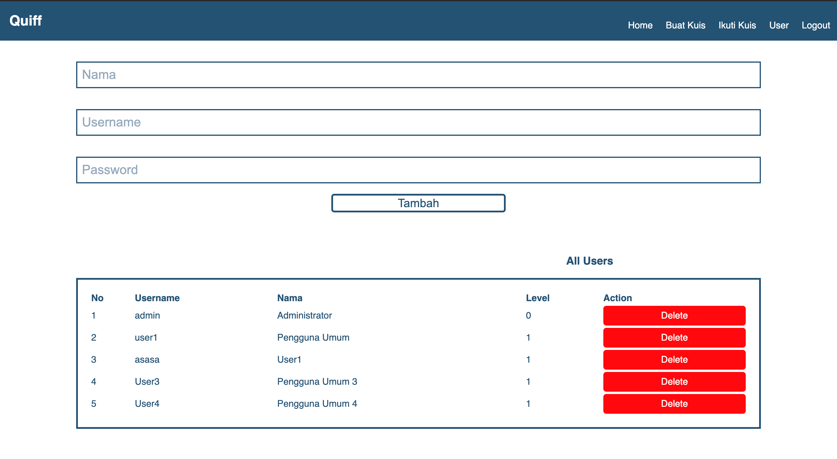

Gambar Halaman Tambah User

|  |
| --- |
| < <!DOCTYPE html>  <html>  <head>  <title>Quiff</title>  <link rel="stylesheet" type="text/css" href="style.css">  </head>  <body class="body1">  <div class="topnav">  <div class="container col c5">  <h2>Quiff</h2>  </div>  <div class="col c17">  <a class="container" href="logout.php">Logout</a>  <a class="container" href="usercontrol.php">User</a>  <a class="container" href="selectquispage.php">Ikuti Kuis</a>  <a class="container" href="createpage.php">Buat Kuis</a>  <a class="container" href="homepage.php">Home</a>  </div>  </div>  <script type="text/javascript">  $('.confirmation').on('click', function () {  *return* confirm('Are you sure want to delete this User?');  });  </script>  <br><br>  <form class="form-create-user" action="createuser.php" method="post" name="create" onsubmit="*return* validateForm1()">  <div class="center col c18">  <input class="inputbox2" type="text" name="nama" placeholder="Nama" required="">  </div>  <br><br>  <div class="center col c18">  <input class="inputbox2" type="text" name="username" placeholder="Username" required="">  </div>  <br><br>  <div class="center col c18">  <input class="inputbox2" type="password" name="password" placeholder="Password" required="">  </div>  <br>  <h3>  <input class="button2 col c4 center" type="submit" name="submit" value="Tambah" style="font-size: 20px; padding: 0.5%">  </h3>  </form>  <br><br><br>  <div class="container space col c9">  <br><br>  </div>  <h3 class="color-blue2 center">All Users</h3>  <div class="container space col c2">  <br>  </div>  <div class="box col c18 box-user">  <table class="user-table" width="100%">  <thead>  <tr>  <th align="left" class="color-blue2" scope="col">No</th>  <th align="left" class="color-blue2" scope="col">Username</th>  <th align="left" class="color-blue2" scope="col">Nama</th>  <th align="left" class="color-blue2" scope="col">Level</th>  <th align="left" class="color-blue2" scope="col">Action</th>  </tr>  </thead>  <tbody>  <tr>  <td class="color-blue2">1</td>  <td class="color-blue2">admin</td>  <td class="color-blue2">Administrator</td>  <td class="color-blue2">0</td>  <td>  <a class="button-danger" href="deleteuser.php?id=1">Delete</a>  </td>  </tr>  <tr>  <td class="color-blue2">2</td>  <td class="color-blue2">user1</td>  <td class="color-blue2">Pengguna Umum</td>  <td class="color-blue2">1</td>  <td>  <a class="button-danger" href="deleteuser.php?id=2">Delete</a>  </td>  </tr>  <tr>  <td class="color-blue2">3</td>  <td class="color-blue2">asasa</td>  <td class="color-blue2">User1</td>  <td class="color-blue2">1</td>  <td>  <a class="button-danger" href="deleteuser.php?id=9">Delete</a>  </td>  </tr>  <tr>  <td class="color-blue2">4</td>  <td class="color-blue2">User3</td>  <td class="color-blue2">Pengguna Umum 3</td>  <td class="color-blue2">1</td>  <td>  <a class="button-danger" href="deleteuser.php?id=10">Delete</a>  </td>  </tr>  <tr>  <td class="color-blue2">5</td>  <td class="color-blue2">User4</td>  <td class="color-blue2">Pengguna Umum 4</td>  <td class="color-blue2">1</td>  <td>  <a class="button-danger" href="deleteuser.php?id=11">Delete</a>  </td>  </tr>  </tbody>  </table>  </div>  <title>Quiff</title>  <link rel="stylesheet" type="text/css" href="style.css">  <div class="col c22"><br><br><br></div>  <div class="topnav footer container">  <div class="col c22"><br></div>  <div class="col c1 "> Nama</div>  <div class="col c21 ">: Vinsensius I Made Surya Aditya</div>  <div class="col c22"><br></div>  <div class="col c1 "> NIM</div>  <div class="col c21 ">: 190030097</div>  <div class="col c22"><br></div>  </div>  </body>  </html> |

Tabel Kode Program - Tambah User

## **Halaman Mengubah Data User Fungsi/Progres F.0.4.2**

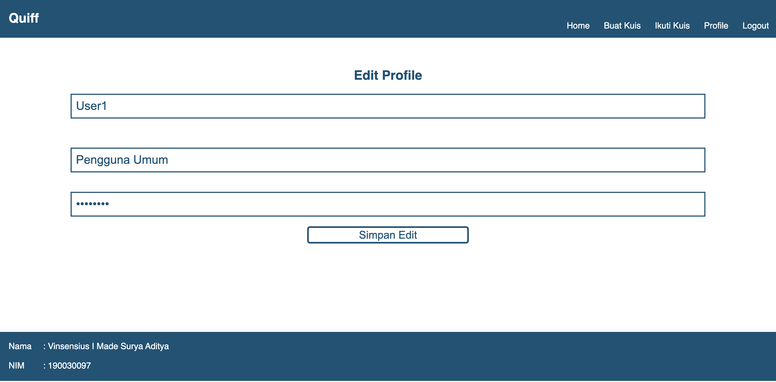

Gambar Halaman Mengubah Data User

|  |
| --- |
| <!DOCTYPE html>  <html>  <head>  <title>Quiff</title>  <link rel="stylesheet" type="text/css" href="style.css">  </head>  <body class="body1">  <div class="topnav">  <div class="container col c2">  <h2>Quiff</h2>  </div>  <div class="col c20">  <a class="container" href="logout.php">Logout</a>  <a class="container" href="edituser.php">Profile</a>  <a class="container" href="selectquispage.php">Ikuti Kuis</a>  <a class="container" href="createpage.php">Buat Kuis</a>  <a class="container" href="homepage.php">Home</a>  </div>  </div>  <br><br>  <h2 class="color-blue2 center">Edit Profile</h2>  <form class="form-create-user" action="edituserprofile.php" method="post" name="create" onsubmit="*return* validateForm1()">  <div class="center col c18">  <input class="inputbox2" type="text" name="nama" placeholder="Nama" value="User1" ?=""> required&gt;  </div>  <br><br>  <div class="center col c18">  <input class="inputbox2" type="text" name="username" placeholder="Username" value="Pengguna Umum" required="">  </div>  <br><br>  <div class="center col c18">  <input class="inputbox2" type="password" name="password" placeholder="Password" value="********" required="">  </div>  <br>  <h3>  <input class="button2 col c4 center" type="submit" name="submit" value="Simpan Edit" style="font-size: 20px; padding: 0.5%">  </h3>  </form>  <br><br><br>  <div class="container space col c9">  <br><br>  </div>  <title>Quiff</title>  <link rel="stylesheet" type="text/css" href="style.css">  <div class="col c22"><br><br><br></div>  <div class="topnav footer container">  <div class="col c22"><br></div>  <div class="col c1 "> Nama</div>  <div class="col c21 ">: Vinsensius I Made Surya Aditya</div>  <div class="col c22"><br></div>  <div class="col c1 "> NIM</div>  <div class="col c21 ">: 190030097</div>  <div class="col c22"><br></div>  </div>  </body>  </html> |

Tabel Kode Program - Mengubah Data User

## **Halaman Menambah Data Kuis Fungsi/Progres F.0.5**

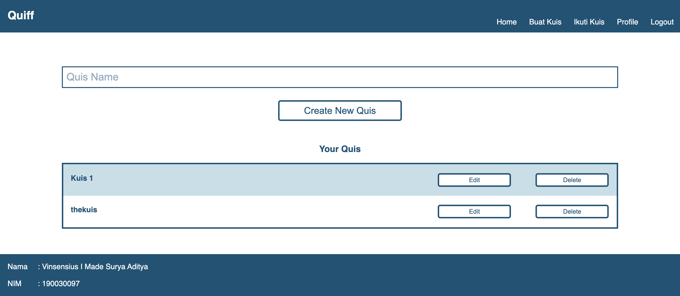

Gambar Halaman Menambah Data Kuis

|  |
| --- |
| <!DOCTYPE html>  <html>  <head>  <title>Quiff</title>  <link rel="stylesheet" type="text/css" href="style.css">  </head>  <body class="body1">  <div class="topnav">  <div class="container col c2">  <h2>Quiff</h2>  </div>  <div class="col c20">  <a class="container" href="logout.php">Logout</a>  <a class="container" href="edituser.php">Profile</a>  <a class="container" href="selectquispage.php">Ikuti Kuis</a>  <a class="container" href="createpage.php">Buat Kuis</a>  <a class="container" href="homepage.php">Home</a>  </div>  </div>  <script>  function validateForm1() {  *var* a = document.forms["create"]["quisname"].value;  if (a == "") {  alert("Quisname must be filled out");  *return* false;  }  }    </script>  <br><br><br><br>  <form action="create.php" method="post" name="create" onsubmit="*return* validateForm1()">  <div class="col c2"><br><br></div>  <div class="col c18">  <input class="inputbox2" type="text" name="quisname" placeholder="Quis Name" required="">  </div>  <br><br>  <div class="col c2"><br><br></div>  <div class="col c9"><br><br></div>  <h3>  <input class="button2 col c4 center" type="submit" name="submit" value="Create New Quis" style="font-size: 20px; padding: 0.5%">  </h3>  </form>  <br><br><br>  <div class="container space col c9">  <br><br>  </div>  <h3 class="color-blue2 center">Your Quis</h3>  <div class="container space col c2">  <br>  </div>  <div class="box col c18">  <form action="actionkuis.php" method="post">  <div class="container color-blue3">  <h4 class="col c15">Kuis 1</h4>  <button type="submit" name="edit" value="11" class="button2 margin col c3 center">  <div class="container">Edit</div>  </button>  <div class="container space col c1">  </div>  <button type="submit" formaction="deletekuis.php" name="deletekuis" value="11" class="button2 margin col c3 center">  <div class="container">Delete</div>  </button>  </div>  <div class="container color-blue4">  <h4 class="col c15">thekuis</h4>  <button type="submit" name="edit" value="12" class="button2 margin col c3 center">  <div class="container">Edit</div>  </button>  <div class="container space col c1">  </div>  <button type="submit" name="deletekuis" formaction="deletekuis.php" value="12" class="button2 margin col c3 center">  <div class="container">Delete</div>  </button>  </div>  </form>  </div>  <title>Quiff</title>  <link rel="stylesheet" type="text/css" href="style.css">  <div class="col c22"><br><br><br></div>  <div class="topnav footer container">  <div class="col c22"><br></div>  <div class="col c1 "> Nama</div>  <div class="col c21 ">: Vinsensius I Made Surya Aditya</div>  <div class="col c22"><br></div>  <div class="col c1 "> NIM</div>  <div class="col c21 ">: 190030097</div>  <div class="col c22"><br></div>  </div>  </body>  </html> |

Tabel Kode Program - Menambah Data Kuis

## **Halaman Ubah Kuis Fungsi/Progres F.0.5.2**

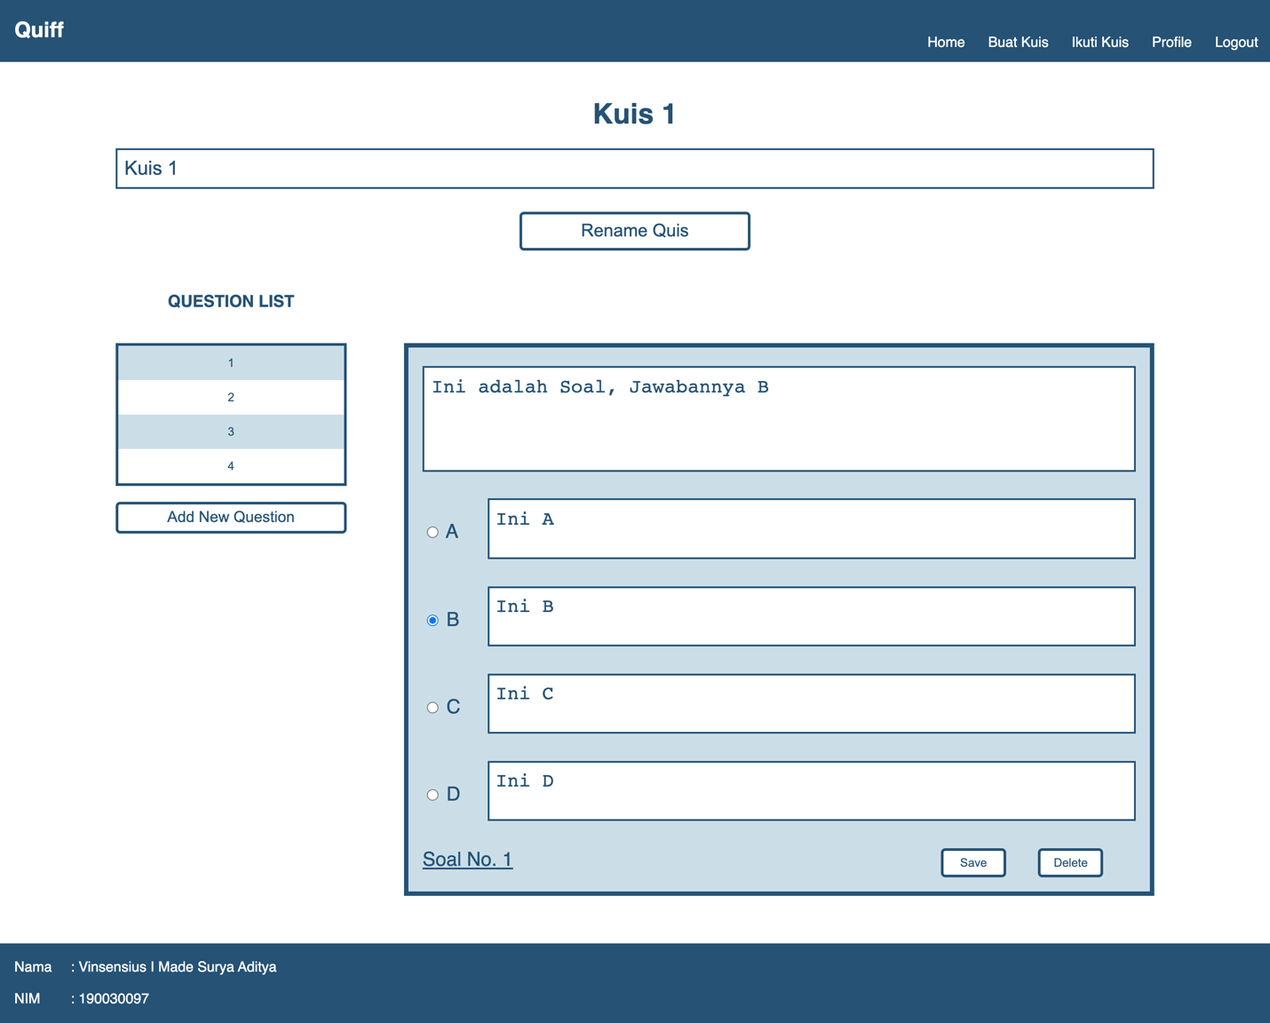

Gambar Halaman Ubah Kuis

|  |
| --- |
| <html>  <head>  <title>Quiff</title>  <link rel="stylesheet" type="text/css" href="style.css">  <script>  function validateForm1() {  *var* a = document.forms["soal"]["pertanyaan"].value;  *var* b = document.forms["soal"]["answer"].value;  *var* c = document.forms["soal"]["ansa"].value;  *var* d = document.forms["soal"]["ansb"].value;  *var* e = document.forms["soal"]["ansc"].value;  *var* f = document.forms["soal"]["ansd"].value;  if (a == "") {  alert("Question must be filled out");  *return* false;  }    if (c == "") {  alert("Option A must be filled out");  *return* false;  }  if (d == "") {  alert("Option B must be filled out");  *return* false;  }  if (e == "") {  alert("Option C must be filled out");  *return* false;  }  if (f == "") {  alert("Option D must be filled out");  *return* false;  }  if (b == "") {  alert("Please choose the correct option");  *return* false;  }  }    </script>  </head>  <body class="body1">  <div class="topnav">  <div class="container col c2">  <h2>Quiff</h2>  </div>  <div class="col c20">  <a class="container" href="logout.php">Logout</a>  <a class="container" href="edituser.php">Profile</a>  <a class="container" href="selectquispage.php">Ikuti Kuis</a>  <a class="container" href="createpage.php">Buat Kuis</a>  <a class="container" href="homepage.php">Home</a>  </div>  </div>  <script>  function validateForm() {  *var* a = document.forms["rename"]["quisname"].value;    if (a == "") {  alert("New Name must be filled out");  *return* false;  }    }    </script>  <br>  <h1 class="color-blue4 center">Kuis 1</h1>  <form action="rename.php" name="rename" id="3" onsubmit="*return* validateForm()">  <div class="col c2"><br><br></div>  <div class="col c18">  <input class="inputbox2" type="text" name="quisname" placeholder="Rename Quis" value="Kuis 1">  </div>  <br><br>  <div class="col c2"><br><br></div>  <div class="col c9"><br><br><br></div>  <h3>  <button class="button2 col c4 center" type="submit" name="rename" value="1" style="font-size: 20px; padding: 0.5%">Rename Quis</button>  </h3>  </form>  <div class="col c9"><br><br><br><br></div>  <br><br><br>  <div class="col c2 color-blue2"><br></div>  <div class="col c4">  <h3 class="color-blue2 center">QUESTION LIST</h3>  <br>  <div class="box">  <form method="get" action="addsoal.php" id="1" name="form1">  <button type="submit" formaction="editsoal.php" name="id_soal" value="27" class=" button3">1</button><button type="submit" formaction="editsoal.php" name="id_soal" value="28" class=" button4">2</button><button type="submit" formaction="editsoal.php" name="id_soal" value="29" class=" button3">3</button><button type="submit" formaction="editsoal.php" name="id_soal" value="30" class=" button4">4</button>  </form>  </div>  <button type="submit" name="add" value="11,4,formaction=&quot;addsoal.php&quot;" class="button2 col c22 margin center">  <div class="container" style="font-size: 1.3em;">Add New Question</div>  </button>  </div>  <br><br>  <br>  <h3><br></h3>  <div class="col c1"><br><br><br><br></div>  <div class="col c13 box color-blue1">  <div class="container inputbox2">  <form action="actioneditsoal.php" method="post" id="2" name="soal" onsubmit="*return* validateForm1()">  <textarea rows="4" name="pertanyaan" placeholder="Empty" cols="50" class="inputbox3" style="resize: none; background-color: #fff; padding: 1%">Ini adalah Soal, Jawabannya B</textarea>  <div class="container col c22"></div>  <div class="col c2 "><br><br>  <input type="radio" id="A" name="answer" value="1">  <label for="A" style="color: #245275">A</label>  </div>  <div class="col c20 "><br>  <textarea rows="2" cols="50" class="inputbox3 option" placeholder="Empty" name="ansa" style="resize: none; background-color: #fff; padding:1%;">Ini A</textarea>  </div>  <div class="container col c22"></div>  <div class="col c2 "><br><br>  <input type="radio" id="B" name="answer" value="2" checked="">  <label for="B" style="color: #245275">B</label>  </div>  <div class="col c20 "><br>  <textarea rows="2" cols="50" class="inputbox3 option" placeholder="Empty" name="ansb" style="resize: none; background-color: #fff; padding:1%;">Ini B</textarea>  </div>  <div class="container col c22"></div>  <div class="col c2 "><br><br>  <input type="radio" id="C" name="answer" value="3">  <label for="C" style="color: #245275">C</label>  </div>  <div class="col c20 "><br>  <textarea rows="2" cols="50" class="inputbox3 option" placeholder="Empty" name="ansc" style="resize: none; background-color: #fff; padding:1%;">Ini C</textarea>  </div>  <div class="container col c22"></div>  <div class="col c2 "><br><br>  <input type="radio" id="D" name="answer" value="4">  <label for="D" style="color: #245275">D</label>  </div>  <div class="col c20 "><br>  <textarea rows="2" cols="50" class="inputbox3 option" placeholder="Empty" name="ansd" style="resize: none; background-color: #fff; padding:1%;">Ini D</textarea>  </div>  <div class="container col c22"><br></div>  <div class="col c16" style="text-decoration: underline;">Soal No. 1</div>  <div>  <button type="submit" name="id_soal" value="27" class="button2 col c2 center" style="margin-bottom:16px">  <div class="container" style="padding:5px; ">Save</div>  </button>  </div>  <div class="col c1"><br></div>  <div>  <form action="deletesoal.php" method="post" name="delete">  <button type="submit" name="id_soal" value="27" onclick="*return* confirm('Are you sure you want to DELETE this Question?');" class="button2 col c2 center"><div class="container" style="padding:5px;">Delete</div></button>  </form></div></form>  </div>  </div>  <link rel="stylesheet" type="text/css" href="style.css">  <div class="col c22"><br><br><br></div>  <div class="topnav footer container">  <div class="col c22"><br></div>  <div class="col c1 "> Nama</div>  <div class="col c21 ">: Vinsensius I Made Surya Aditya</div>  <div class="col c22"><br></div>  <div class="col c1 "> NIM</div>  <div class="col c21 ">: 190030097</div>  <div class="col c22"><br></div>  </div>  </body>  </html> |

Tabel Kode Program - Ubah Kuis

## **Halaman Buat Soal Kuis Fungsi/Progres F.0.5.3**

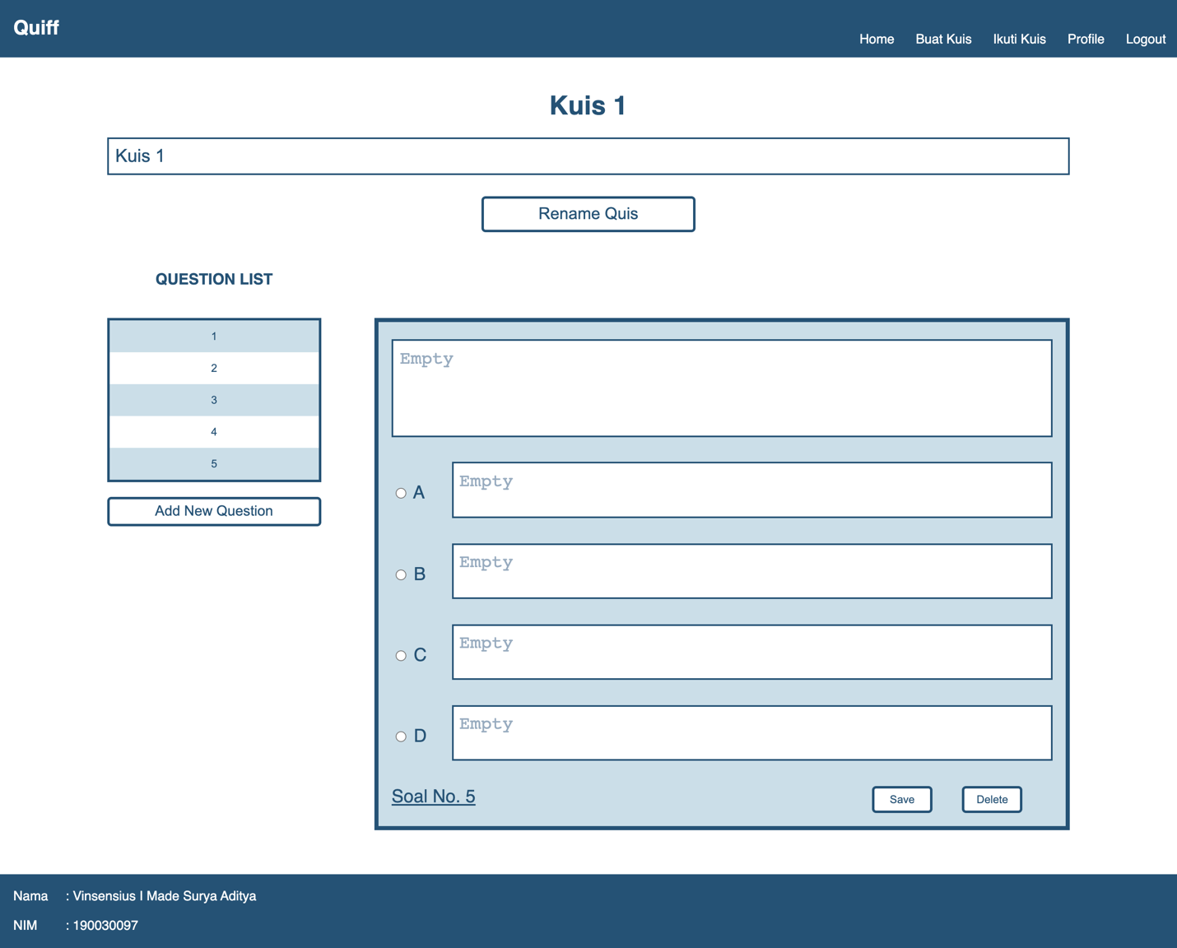

Gambar Halaman Buat Soal Kuis

|  |
| --- |
| <html>  <head>  <title>Quiff</title>  <link rel="stylesheet" type="text/css" href="style.css">  <script>  function validateForm1() {  *var* a = document.forms["soal"]["pertanyaan"].value;  *var* b = document.forms["soal"]["answer"].value;  *var* c = document.forms["soal"]["ansa"].value;  *var* d = document.forms["soal"]["ansb"].value;  *var* e = document.forms["soal"]["ansc"].value;  *var* f = document.forms["soal"]["ansd"].value;  if (a == "") {  alert("Question must be filled out");  *return* false;  }    if (c == "") {  alert("Option A must be filled out");  *return* false;  }  if (d == "") {  alert("Option B must be filled out");  *return* false;  }  if (e == "") {  alert("Option C must be filled out");  *return* false;  }  if (f == "") {  alert("Option D must be filled out");  *return* false;  }  if (b == "") {  alert("Please choose the correct option");  *return* false;  }  }    </script>  </head>  <body class="body1">  <div class="topnav">  <div class="container col c2">  <h2>Quiff</h2>  </div>  <div class="col c20">  <a class="container" href="logout.php">Logout</a>  <a class="container" href="edituser.php">Profile</a>  <a class="container" href="selectquispage.php">Ikuti Kuis</a>  <a class="container" href="createpage.php">Buat Kuis</a>  <a class="container" href="homepage.php">Home</a>  </div>  </div>  <title>projek uas</title>  <link rel="stylesheet" type="text/css" href="style.css">  <script>  function validateForm() {  *var* a = document.forms["rename"]["quisname"].value;    if (a == "") {  alert("New Name must be filled out");  *return* false;  }    }    </script>  <br>  <h1 class="color-blue4 center">Kuis 1</h1>  <form action="rename.php" name="rename" id="3" onsubmit="*return* validateForm()">  <div class="col c2"><br><br></div>  <div class="col c18">  <input class="inputbox2" type="text" name="quisname" placeholder="Rename Quis" value="Kuis 1">  </div>  <br><br>  <div class="col c2"><br><br></div>  <div class="col c9"><br><br><br></div>  <h3>  <button class="button2 col c4 center" type="submit" name="rename" value="1" style="font-size: 20px; padding: 0.5%">Rename Quis</button>  </h3>  </form>  <div class="col c9"><br><br><br><br></div>  <br><br><br>  <div class="col c2 color-blue2"><br></div>  <div class="col c4">  <h3 class="color-blue2 center">QUESTION LIST</h3>  <br>  <div class="box">  <form method="get" action="addsoal.php" id="1" name="form1">  <button type="submit" formaction="editsoal.php" name="id_soal" value="27" class=" button3">1</button><button type="submit" formaction="editsoal.php" name="id_soal" value="28" class=" button4">2</button><button type="submit" formaction="editsoal.php" name="id_soal" value="29" class=" button3">3</button><button type="submit" formaction="editsoal.php" name="id_soal" value="30" class=" button4">4</button><button type="submit" formaction="editsoal.php" name="id_soal" value="31" class=" button3">5</button>  </form>  </div>  <button type="submit" name="add" value="11,5,formaction=&quot;addsoal.php&quot;" class="button2 col c22 margin center">  <div class="container" style="font-size: 1.3em;">Add New Question</div>  </button>  </div>  <br><br>  <br>  <h3><br></h3>  <div class="col c1"><br><br><br><br></div>  <div class="col c13 box color-blue1">  <div class="container inputbox2">  <form action="actioneditsoal.php" method="post" id="2" name="soal" onsubmit="*return* validateForm1()">  <textarea rows="4" name="pertanyaan" placeholder="Empty" cols="50" class="inputbox3" style="resize: none; background-color: #fff; padding: 1%"></textarea>  <div class="container col c22"></div>  <div class="col c2 "><br><br>  <input type="radio" id="A" name="answer" value="1">  <label for="A" style="color: #245275">A</label>  </div>  <div class="col c20 "><br>  <textarea rows="2" cols="50" class="inputbox3 option" placeholder="Empty" name="ansa" style="resize: none; background-color: #fff; padding:1%;"></textarea>  </div>  <div class="container col c22"></div>  <div class="col c2 "><br><br>  <input type="radio" id="B" name="answer" value="2">  <label for="B" style="color: #245275">B</label>  </div>  <div class="col c20 "><br>  <textarea rows="2" cols="50" class="inputbox3 option" placeholder="Empty" name="ansb" style="resize: none; background-color: #fff; padding:1%;"></textarea>  </div>  <div class="container col c22"></div>  <div class="col c2 "><br><br>  <input type="radio" id="C" name="answer" value="3">  <label for="C" style="color: #245275">C</label>  </div>  <div class="col c20 "><br>  <textarea rows="2" cols="50" class="inputbox3 option" placeholder="Empty" name="ansc" style="resize: none; background-color: #fff; padding:1%;"></textarea>  </div>  <div class="container col c22"></div>  <div class="col c2 "><br><br>  <input type="radio" id="D" name="answer" value="4">  <label for="D" style="color: #245275">D</label>  </div>  <div class="col c20 "><br>  <textarea rows="2" cols="50" class="inputbox3 option" placeholder="Empty" name="ansd" style="resize: none; background-color: #fff; padding:1%;"></textarea>  </div>  <div class="container col c22"><br></div>  <div class="col c16" style="text-decoration: underline;">Soal No. 5</div>  <div>  <button type="submit" name="id_soal" value="31" class="button2 col c2 center" style="margin-bottom:16px">  <div class="container" style="padding:5px; ">Save</div>  </button>  </div>  <div class="col c1"><br></div>  <div>  <form action="deletesoal.php" method="post" name="delete">  <button type="submit" name="id_soal" value="31" onclick="*return* confirm('Are you sure you want to DELETE this Question?');" class="button2 col c2 center"><div class="container" style="padding:5px;">Delete</div></button>  </form></div></form>  </div>  </div>  <div class="col c22"><br><br><br></div>  <div class="topnav footer container">  <div class="col c22"><br></div>  <div class="col c1 "> Nama</div>  <div class="col c21 ">: Vinsensius I Made Surya Aditya</div>  <div class="col c22"><br></div>  <div class="col c1 "> NIM</div>  <div class="col c21 ">: 190030097</div>  <div class="col c22"><br></div>  </div>  </body>  </html> |

Tabel Kode Program - Buat Soal Kuis